Software Requirements Specification

For Minor Project

Shellinabox



|  |  |
| --- | --- |
| Prepared by:  Vijaya Nandwana  Riya Gupta  Achal Sharma | Guide:  Mr. Amol Saxena  Head Of Department (Information Technology) |
| Department of Information Technology,  Poornima College of Engineering  12August2018 Session – 2018-19 | |
|  | |

Table of Contents

|  |  |
| --- | --- |
| Table of Contents | Page No. |
| 1. Introduction |  |
| 1.1 Purpose |  |
| 1.2 Feasibility |  |
| 2. Functional /Nonfunctional Requirements |  |
| 2.1 Functional Requirement |  |
| 2.2 Nonfunctional Requirements |  |
| 2.3 Technical Requirments ( Hardware /Software) |  |
| 3. System Features |  |
| 3.1 Module 1 |  |
| 3.1 Module 2 |  |
| 3.1 Module 3 |  |
| 3.1 Module 4 |  |
| 4. Analysis Diagrams |  |
| 4.1 Use Case Diagram  4.2 Sequence Diagram  4.3 Component diagram  4.4 Data Flow Diagram(Optional)  4.5 ER Diagram  4.6 Activity Diagram  4.7 Project Schedule Diagram |  |
| 5. Other Requirements |  |
| 6. Glossary |  |
| 7. Appendices |  |
| 8. References |  |
| 9. Guide’s Comments |  |

Revision History

|  |  |  |  |
| --- | --- | --- | --- |
| **Name** | **Date** | **Reason For Changes** | **Version** |
|  |  |  |  |
|  |  |  |  |
|  |  |  |  |

# Introduction

## 1.1 Purpose

This project ‘Shellinabox’to a user in which the user gets its personal cloud service. It is planned to satisfy everyone’s expectations. The Shellinabox is intended to provide a quick, easy and user-friendly cloud based services like (Software as a service)SaaS , (Platform as a service)PaaS , (Container as a service)CaaS , (Infrastructure as a service) IaaS , (Storage as a service)StaaS and data analytics which is done through hadoop services. The system should be designed so that management time is minimized and the product is available to clients at a very economical price. All the Services are available under a single portal. We are giving these services through a web page which has a authentication page in which we provide three way of authentication that is Face detection , speech recognition and user-id and password. After sign up its user choice that either they want email or speech or face detection for sign in there cloud.In this application user have to some charge for using services on hour base.

**1.2 Feasibility**

The web interface reduces the effort and time of the clients. People spend a lot of time in finding an appropriate platform which provide secure services.This web interface serves their purpose by giving them better user experience without much investment. The web interface will be made accessible to Enterprise, Professionals and Students. The data deployed by the users is secure and have backups also there is no fear of losing confidential data. The services are made accessible to the targeted clients using WebUI Techniques which makes it easier for the clients to access these services. The user will be able to access the shell within very low cost and is available to user in any time required.

## Functional /Nonfunctional Requirements

## Functional Requirements

1. **Container:**

Containers as a service (CaaS) is a cloud service that allows software developers to upload, organize, run, scale, manage and stop containers by using a provider's API calls or a web portal interface.

1. **Platform**:

Platform as a Service (PaaS) or platform base service is a category of cloud computing services that provides a platform allowing customers to develop, run, and manage applications without the complexity

1. **Storage**:

Storage as a service (SaaS) is a business model in which a company leases or rents its storage infrastructure to another company or individuals to store data.

1. **Software**:

Software as a service (SaaS) is a software distribution model in which a third-party provider hosts applications and makes them available to customers over the Internet.

1. **Infrastructure** :

Infrastructure as a service (IaaS) is a form of cloud computing that provides virtualized computing resources over the internet.

1. **Highly Automated** :

The Web-App should promote “One Click Feature” which focuses on maximum automation. The portal should be designed in a way that reduces the efforts of the user. The user should not indulge in any kind of complexity while dealing with it.

1. **24x7 Availability :**

The server should not loose connectivity with its clients. It should be available 24x7 for its users.

1. **Secure client details :**

The details shared by the user with the server should be considered confidential and should not be miss used under any circumstances.

1. **BackUp of Data :**

The server should keep the backup of the data in case of any loss .

1. **Hadoop Services:**

Hadoop is a big data analytics framework that stores and analyzes data in the cloud using Hadoop.Users don’t have to invest in or install additional infrastructure on premises when using the technology, as HaaS is provided and managed by a third-party vendor. The open source Hadoop big data analytics framework allows large, unstructured data sets to be analysed. Hadoop’s storage mechanism, the Hadoop Distributed File System,distributes these workloads across multiple nodes so they can be processed in parallel. MapperReducer will be used for the processing of the data as per the user requirement. Spark and Hive is also used for the analysis of data which the user upload .

## 2.2 Nonfunctional Requirements

## Performance Requirements

1. **Good User Interface:**

The Web interface should be designed in a way that the user finds it easy to deal with.The interfacing should be made with maximum level of abstraction i.e. showing only the necessary details. The user should be free from any kind of uploading and downloading process to access the Server side. The user who provide us with the true information will be able to access it.

1. **Fast Deployment**:

There should be fast deployment of data on the server. The client should not have to wait due to bad processing speed

1. **Good User Experience**:

The Web interface will be designed to minimize the efforts of the user. It should not ask for user input at every step of processing.

1. **Reliable**:

The user data will be confidential and will not be misused under any condition.

## Safety Requirements

1. **Privileged Users**:

The clients of server will be provided privileged rights for accessing its personal data and containers. No user is allowed to read or edit the information of the other users. The user will not face “Permission Denied“errors.

1. **Active Database**:

The database will contain the details of the most recent activities of the clients, the data stored by the client and the analyzed data.

1. **Data Integrity**:

The user data will be confidential at every point of time. As for every single user a Container is launched by his name which will be accessed by the user only .

## Security Requirements

1. **Secure Data:**

The Web-App uses Password Based Authentication.

1. **User Management:**

All the information about the user is saved and secure.

## Software Quality Attributes

1. **24x7 Availability**:

The cloud will be available 24x7 for its clients.

1. **Availability of new and updated Software**:

It will be the responsibility of the server to entertain its clients with latest up to date software.

1. **Ease Of Data Analytics:**

The data of the user is analyzed according to the needs and requirement.

## 2.3 Technical Requirments ( Hardware /Software)

## Operating Environment

Red Hat Enterprise Linux 7 beta is ready for whatever infrastructure choices you make, efficiently integrating with other operating environment, authentication, and management systems. Whether your primary goal is to build network-intensive applications, massively scalable data repositories, or a build-once-deploy-often solution that performs well in physical, virtual, and cloud environments, Red Hat Enterprise Linux 7 beta has functionality to support the project.You’ll have better insights into what the system is doing and more controls to optimize it, with unified management tools and system-wide resource management that reduce the administrative burden. Container-based isolation and enhanced performance tools allow you to see and adjust resource allocation to each application. And, of course, there are continued improvements to scalability, reliability, and security. Developers and Dev-Ops: Red Hat Enterprise Linux 7 beta has more than just operating system functionality. It provides a rich application infrastructure with built-in mechanisms for security, identity management, resource allocation, and performance optimization. In addition to well-tuned default behaviors, you can take advantage of controls for application resources so you don’t leave performance up to chance. Red Hat Enterprise Linux 7 beta includes the latest stable versions of the most in-demand programming languages, databases, and runtime environments.

## Hardware Interfaces

Submit jobs with the associated deadline, cost, and execution time .Query the cluster to establish the current cost per unit time for submitting new jobs .Monitor the status of submitted jobs. Cancel jobs submitted by user. Check his usage history.The client can get connected to user whenever required according to the needs.

## Software Interfaces

**File Systems**: Red Hat Enterprise Linux now supports XFS file systems that are up to 500TB in size. The previous support limit was 100TB.

• Ext4 supports a file system that is 50TB in size, up from 16TB.

•The Red Hat Enterprise Linux PNFS client now supports all commercially available server layout types.

DOCKER

Docker is a computer program that performs operating-system-level virtualization, also known "containerization". It was first released in 2013 and is developed by Docker, Inc.

Docker is used to run software packages called "containers". Containers are isolated from each other and bundle their own tools, libraries and configuration files; they can communicate with each other through well-defined channels. All containers are run by a single operating system kernel and are thus more lightweight than virtual machines. Containers are created from "images" that specify their precise contents. Images are often created by combining and modifying standard images downloaded from public repositories.

ANSIBLE

Ansible is open source software that automates software provisioning, configuration management, and application deployment. Ansible connects via SSH, remote PowerShell or via other remote APIs.

The design goals of Ansible include:

• Minimal in nature. Management systems should not impose additional dependencies on the environment.

• Consistent. With Ansible one should be able to create consistent environments.

• Secure. Ansible does not deploy agents to nodes. Only OpenSSH and Python are required on the managed nodes.

• Highly reliable. When carefully written, an Ansible playbook can be idempotent, in order to prevent unexpected side-effects on the managed systems.[16] It should be noted, however, that it is entirely possible to have a poorly written playbook that is not idempotent.

**Security**: With firewall, a firewall does not have to be stopped in order to change its rules. This increases the security of the system by eliminating vulnerability and adding the ability to respond to threats by quickly activating new rules. In addition to dynamic configuration capabilities, firewall supports a powerful rules language that simplifies configuring firewalls.

## Communications Interfaces

The product is designed to provide better user experience. For Web UI Html, CSS, Bootstrap, JAVA Script is used to improve the look and feel of the Web interface. The Web interface uses python-cgi to interact with the clients. Python-cgi makes it easier for the clients to interact with the server model.

The network Server Communication Protocols like HTTP, SSH, NFS, iSCSI, DockerAPI are used to communicate with the clients.

# System Features

## Module 1: System features of Module1

**HIGH PRIORITY**

**Module 1: Python Audio**

1. Using Python Text to Speech for speech. This will be aid to the blinds.Pyttsx is a good text to speech conversion library in python. **Pyttsx3 library now works for both python2 and python3 and is also cross-platform.**

**Module 2: Registration (Database)**

1. Entire details of all the users and their logs will be maintained in database. It will be managed by the Database Administrator.

**MEDIUM PRIORITY**

**Module 3: Storage**

1. StaaS provides space to the users. It contains two categories- Object Storage as a Service and Block Storage as a Service. StaaS uses the concepts of Partioning, Formatting, Mounting, iSCSI.
2. The project’s aim is to implement a standards based storage architecture and an initial range of services to address current demands, is scalable, available on-demand and online, and with the potential to be integrated with other storage platforms, whether centrally, locally or cloud provided.

**Module 4: Platform**

1. PaaS provides platform to its users. Here the user is provided Python2, Python3, JAVA and many more platforms to its clients.

**Module 5: Container**

**5.1** Container Technology helps the individual client to manage its own personal container. As it provides every user with its own personal container having all the requirement wihich the user want as per metioned by the shell.

**Module 6: Software**

1. SaaS provides useful and updated softwares to the users. The CSP ensures that the softwares are not corrupted and as per the requirement of the client.
2. SaaS applications run on a **SaaS** provider's servers. Instead of installing and maintaining software, you simply access it via the Internet like notepad,vlc,jupyter notebook etc.

**Module 7: Infrastructure**

1. Infrastructure as a service (IaaS) is a form of cloud computing that provides virtualized computing resources over the internet. IaaS helps you avoid the expense and complexity of buying and managing your own physical servers and other datacenter infrastructure

**Module 8: Data Analytics(Hadoop)**

**8.**1 **Apache Hadoop** is a 100 percent open source framework that pioneered a new way for the distributed processing of large, enterprise data sets. Instead of relying on expensive, and different systems to store and process data, Hadoop enables distributed parallel processing of huge amounts of data across inexpensive, industry-standard servers that both store and process the data. With Hadoop, no data is too [big data](https://www.happiestminds.com/services/big-data/).

# 8.2 HIVE:The Apache Hive data warehouse software facilitates querying and managing large datasets residing in distributed storage. Hive provides a mechanism to project structure onto this data and query the data using a SQL-like language called HiveQL. At the same time this language also allows traditional map/reduce programmers to plug in their custom mappers and reducers when it is inconvenient or inefficient to express this logic in HiveQL.Support for exporting metrics via the Hadoop metrics subsystem to files or Ganglia; or via JMX.

# 8.3 Pig:Pig is a platform for analyzing large data sets that consists of a high-level language for expressing data analysis programs, coupled with infrastructure for evaluating these programs. The salient property of Pig programs is that their structure is amenable to substantial parallelization, which in turns enables them to handle very large data sets. At the present time, Pig’s infrastructure layer consists of a compiler that produces sequences of Map-Reduce programs, for which large-scale parallel implementations already exist (e.g., the Hadoop subproject). Pig’s language layer currently consists of a textual language called Pig Latin.

# Other Requirements

We will use sql here for database .we use sql for the database which will be updated regularlyby user.We can provide our products to students on the basis of freesubscription of oneyear for the

Learning purpose .Here students can implement new techonolgy in free of cost for an year.

# Glossary

|  |  |
| --- | --- |
| RHEL | Red Hat Enterprise Linux |
| CSP | Cloud Service Provider |
| SRS | Software Requirement Specification |
| HTTP | Hyper Text Transfer Protocol |
| SQL | Structure Query Language |
| API | Application Programmable Interface |
| CaaS | Container as a Service |
| PaaS | Platform as a Service |
| StaaS | Storage as a Service |
| IaaS | Infrastructure as a Service |
| SaaS | Software as a Service |
| NFS | Network File System |

# Analysis Diagrams

* **System Chart / Modul**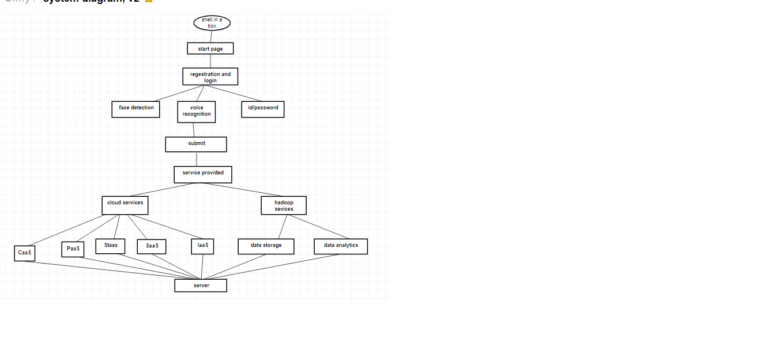
* **Sequence Diagram:**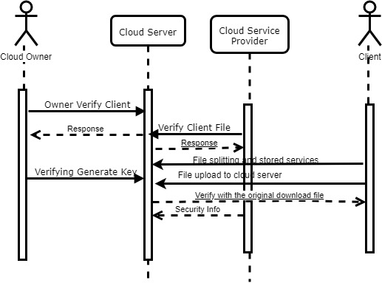
* **UseCase:**

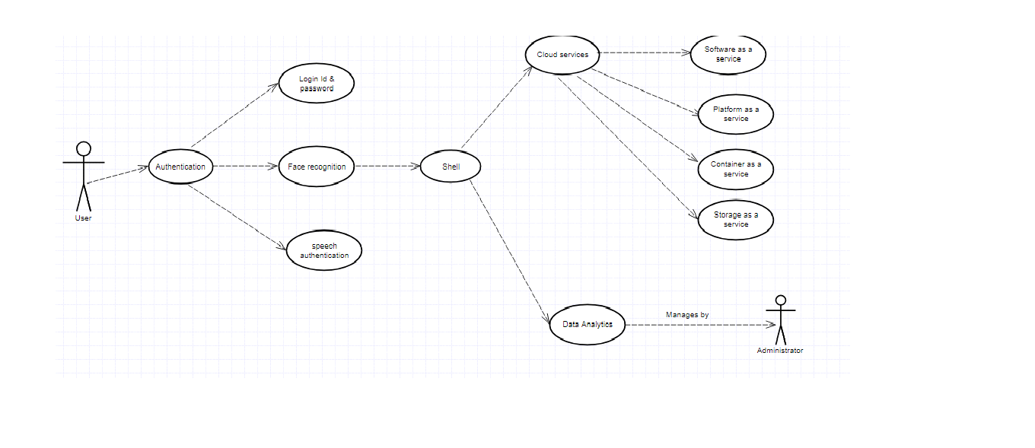

* **Deployment Diagram**

**C:\Users\User\Downloads\final deploy.png**

# References

* www.redhat.com
* www.searchcloudcomputing.techtarget.com
* www.techopedia.com
* access.redhat.com
* <http://w3schools.com>

# Guide’s Comments

-----------------------------------------------------------------------------------------------------------------------------------------------------------------------------------------------------------------------------------------------------------------------------------------------------------------------------------------------------------------------------------------------------------